**Play Store App Review Analysis**

**Prashant Singh**

**Sachin**

**Jaanhvi khandelwal**

**Pankaj Kumar Pandit**

**Abstract:**

The Google play store is one of the largest and most popular Android app stores. It has an enormous amount of data that can be used to make an optimal model. We have used Play Store data from the team capstone project dashboard. This data set contains 13 different features that can be used for predicting key factors responsible for app engagement & success stories.

**INTRODUCTION:-**

Mobile applications are absolutely vital because specific software is required for almost every purpose be it personal, social, business & for any such functions. It is one of the fastest-growing segments of downloadable software application markets It has become more important as the android market has gone to a real amelioration among mankind over the last decade. One of the main reasons for this popularity is the fact that about 81% of the apps are free of cost. The market has increased to over 3.5 million Apps and around 3000+ apps are being added per day as per a Google survey report. Thus, the market, in turn, led to around 5 billion users downloading all over the world. Developers and users play key roles in determining the impact that market interactions have on future technology. However, the lack of a clear understanding of the inner working and dynamics of popular app markets impacts both the developers and users. This journal talks

about the dynamics of the Play Store app & analyzes the actionable insights for the developers to work on and capture the Android market and also analyzes factors for app engagement and success with classifier models used for finding the user engagement, success parameters, and the complete Data visualization.

**INTEGRAL METHODOLOGY**

The entire Analysis is divided into the following phases: Dataset Description, Breakdown of Datasets, Examining the null values & missing values, Data Cleaning, followed by Exploratory Data Analysis by and applying different models. First, we collect the data from Alma's better dashboard. Thereafter we did basic data cleaning and data visualization. After visualizing the data set, we removed some unnecessary features and made it ready for analyzing the data set using different plots. Next, we conduct data modelling by using Bar plot graphs, violin plots, density plots, etc. Finally, we narrate the analysis results to provide a clear vision of the relationship among the areas of interest.

## **DATASET DESCRIPTION**

Let's take a look at the data, which consists of two files: playstore.csv: contains all the details of the applications on Google Play. There are 13 features that describe a given app. user_reviews.csv: contains 100 reviews for each app, most helpful first. The text in each review has been preprocessed and attributed with three new features: Sentiment (Positive, Negative or Neutral), Sentiment Polarity and Sentiment Subjectivity,. About Dataset Most regularly a dataset relates to the matter of the single database table, or the single factual information framework, where each segment of the table speaks to a specific variable, and each column compares to a given individual from the informational collection being referred to. This dataset has 13 columns of varied categories of the appliance. In this project, I have analyzed all these various columns of the dataset.

|  |  |
| --- | --- |
| App | Name of the app. |
| Category | Category in which it falls. |
| Rating | Application’s rating on play store. |
| Reviews | No. of reviews of the app. |
| Size | Size of the app. |
| Installs | Number of installs of the app. |
| Type | If the app is free or paid. |
| Price | Price of the app on the play store. |
| Content Rating | Appropriate target audience. |
| Genres | Genre of the app under which it falls. |
| Last updated | Date when the app was last updated. |
| Current version | Current version of the app. |
| Android version | Minimum android version required to run the app. |

**BREAKDOWN OF DATASETS:-**

In order to go ahead for data visualization upon key factors we need to go for certain extra steps before proceeding to the main segment. In this part we are going with the following steps:-

1. Importing Analytical necessary library classes for future analysis.
2. Reading the csv data file from Google drive.
3. Setting figure size for future visualization.
4. Removing future warnings in seaborne plots.
5. Visualizing all the columns of the respective Data frame.
6. Viewing all data information
7. Checking the Unique values in the column (if any)
8. Converting the data types to similar objects as the Analysis Demands.
9. Formatting the “size” column into a single column in the dataset.
10. Eradicating special characters from the dataset columns.

# **EXAMINING NULL VALUES**

The most critical thing from which we can draw some observations is Dataset, however data comes with unexpected values too i.e. sometimes it may be Null or missing in other words the space might be blank. Thus, at the time of analyzing the first thing which we will do is to examine the null or missing values on the Dataset. It is the first step that will make the results “more” accurate &should be handled before it affects the performance of the models that predict the outcome. By plotting a graph it can be seen that missing values are more in Size & Rating columns. Hence, several methods to eradicate those null values.

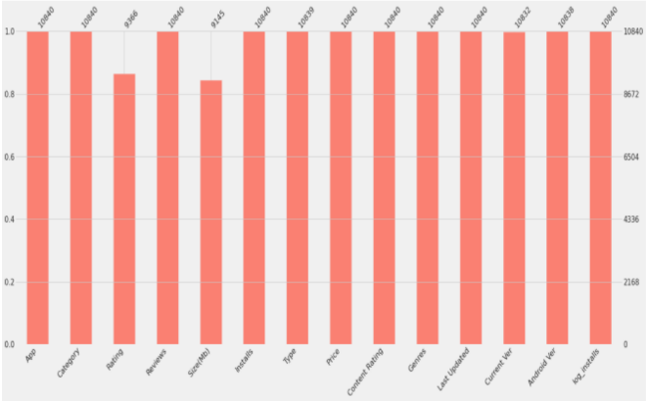

**DATA CLEANING:-**

Data cleaning is one of the most essential subtask of any data science project. Although it can be a very tedious process, it's worth should never be undermined.

By looking at a random sample of the dataset rows (from the above task), we observe that some entries in the columns like Installs, Price and Size have a few special characters (+ , $ ,M , k) .This prevents the columns from being purely numeric, making it difficult to use them in subsequent future mathematical calculations. Ideally, as their names suggest, we would want these columns to contain only digits from [0-9]. Hence, we now proceed to clean our data. Specifically, the special characters "," and "+" present in Installs column and "$" present in Price column need to be removed. By finding all unique values of each row the inappropriate values can be identified. Different methods can then be used for removing them or to change those values accordingly to use them to make predictions better. As the proverb goes by saying “More Data beats clever algorithm, but better data beats more Data” – Peter Norvig.So going with the method firstly we have found the categorical null values and replacing them by a textual string, secondly finding out the numerical ‘Nan’ values & replacing them with the median of that respective column. After we have check the entire datasets for any null values (if, any exists after eradicating). Now, cleaning all the null values we would drop certain labels/columns which is unnecessary for actionable insights. Therefore, we are can proceed for the Exploratory Data Analysis and observations regarding the datasets.

**DATA VISUALIZATIONS: -**

**Observation-1**

**Exploring app categories**

* With more than 1 billion active users in 190 countries around the world, Google Play continues to be an important distribution platform to build a global audience. For businesses to get their apps in front of users, it’s important to make them more quickly and easily discoverable on Google Play. To improve the overall search experience, Google has introduced the concept of grouping apps into categories. Which category has the highest share of (active) apps in the market? Is any specific category dominating the market? Which categories have the fewest number of apps?
* We will see that there are 33 unique app categories present in our dataset. Family and Game apps have the highest market prevalence. Interestingly, Tools, Business and Medical apps are also at the top.
* As data analyst, we can use this information to decide our future insights.

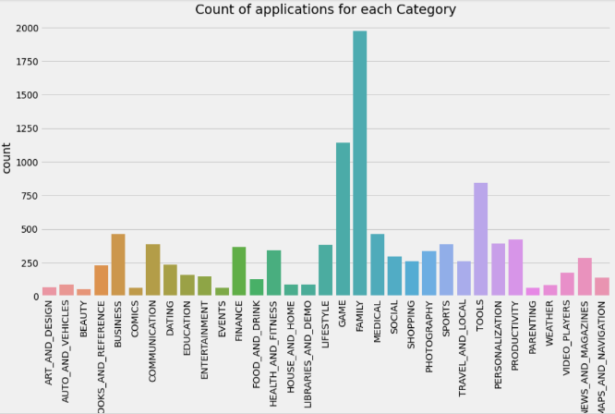

**Observation-2**

**Installs according to genres:-**

* As we can see communication genre has the highest number of installs in this genre social media apps like whatsapp and Gmail are included which has a huge number of customer base as everyone in this day and age uses social media apps.
* Then it is followed by social media apps and then productivity and follows.
* Most number of installs are in communication and social media genre in this genre apps like whatsapp,gmail,facebook.So if a developer wants to develop an app then the apps which falls into this genre will most likely to be popular.

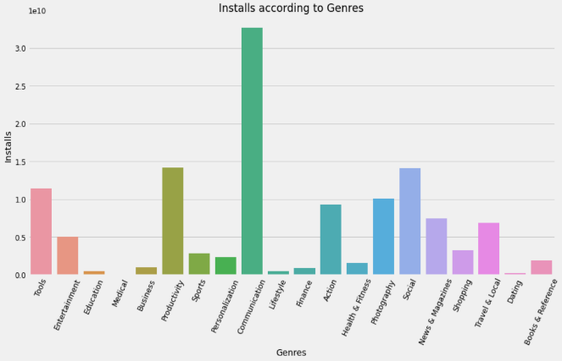

**Observation-3**

## **Heatmap of the Dataset:-**

* Next we can easily visualize the correlations between ‘Installs’ with other columns.
* Certain visualization depicts that it is absolutely uncorrelated except ‘Reviews’.
* Reviews have correlation of 0.64 with installs lets look into this.
* "Installs" vs "Reviews" have a correlation value of 0.64, shows perfect and strong correlation from above line chart as both "installs" and "Reviews" follow the same pattern approximately.
* With more installs, more reviews will come to our dataset. So they are more codependent.

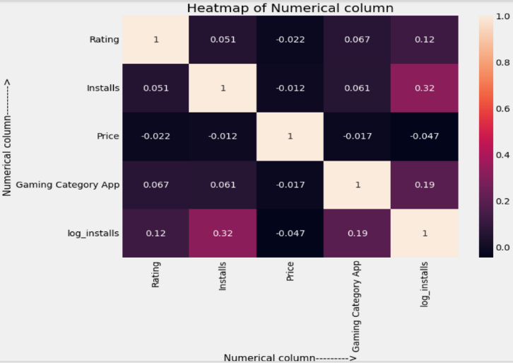

**Observation-4**

**Violin plot of Rating**

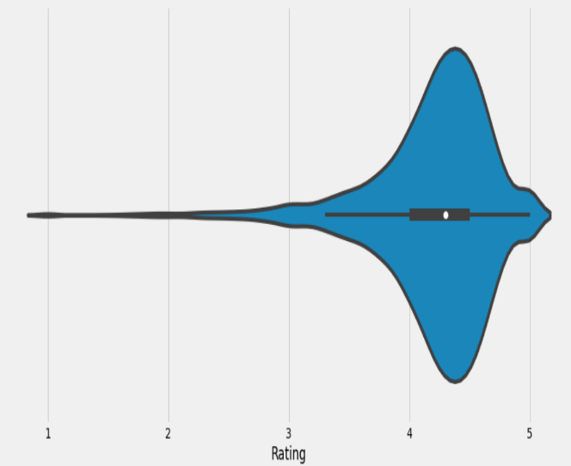

* After having witnessed the market share for each category of apps, let’s see how all these apps perform on an average. App ratings (on a scale of 1 to 5) impact the discoverability, conversion of apps as well as the company’s overall brand image. Ratings are a key performance indicator of an app.
* From our research, we found that the average volume of ratings across all app categories is 4.17. The violin plot plot is broad between 4 and 5 indicating that the majority of the apps are highly rated with only a few exceptions in the low-rated apps.

**Observation-5**

**Count of applications in each category differentiated by their type:-**

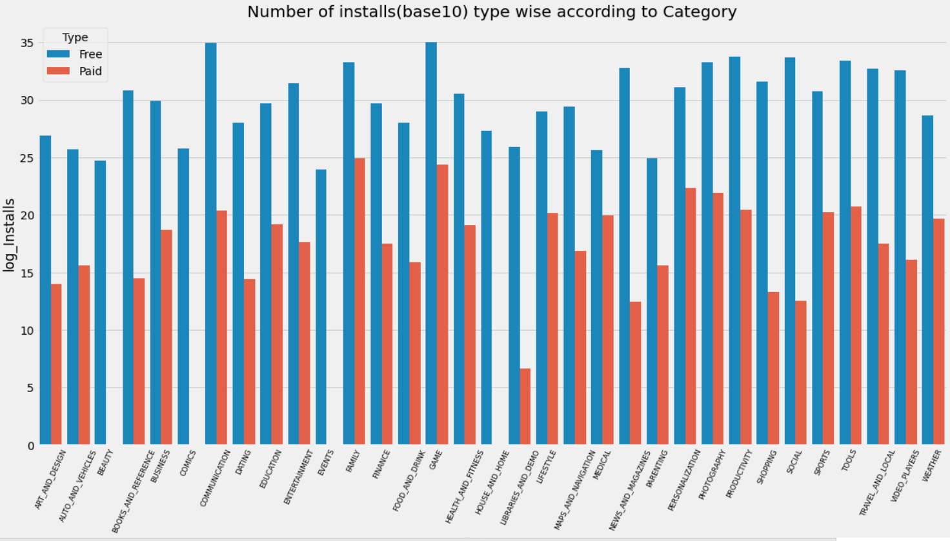

* It looks like certain app categories have more free apps available for download than others. These majority of apps in the Family, Food & Drink, and Tools, as well as Social categories were free to install.
* At the same time Family, Sports, Tools, and medical categories had the biggest number of paid apps available for download.
* We can see that apps which are free have more number of installs as compare to paid apps.These apps earn by add revenue i.e by showing adds to the users.

**Observation-6**

### **Distribution of subjectivity:-**

* Let's dive deep down into sentiments to see a more depth understanding of sentiment Polarity and Subjectivity.

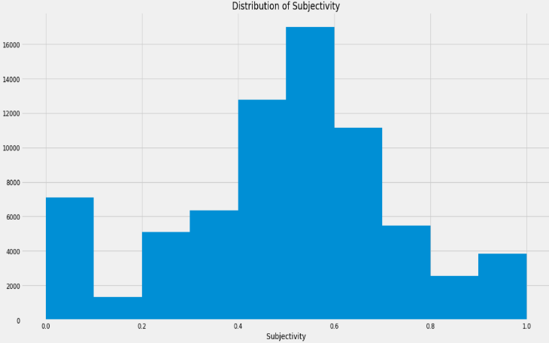

* It can be seen that maximum number of sentiment subjectivity lies between 0.4 to 0.7. From this we can conclude that maximum number of users give reviews to the applications, according to their experience.

**Observation-7**

### **What is the distribution of type of reviews in the dataset?**

* First we will merge our 2 DataFrames into a single DataFrame:- In the merged dataframe, we have three new columns i.e.. Sentiment, Sentiment Polarity and Sentiment Subjectivity. Sentiment basically determines the attitude or the emotion of the writer, i.e., whether it is positive or negative or neutral. Sentiment Polarity is float which lies in the range of [-1,1] where 1 means positive statement and -1 means a negative statement. Sentiment Subjectivity generally refer to personal opinion, emotion or judgment, which lies in the range of [0,1].

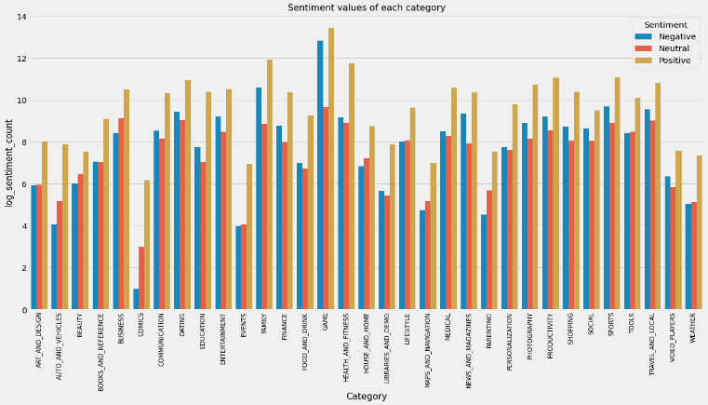

**Observation-8**

## **Does sentiment subjectivity proportional to sentiment polarity?**

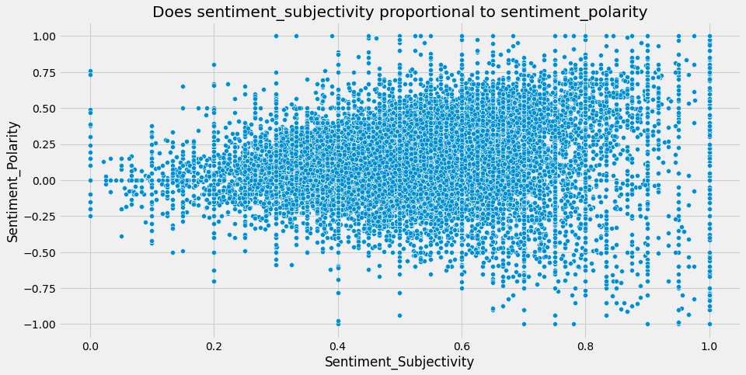

* From the above scatter plot it can be concluded that sentiment subjectivity is not always proportional to sentiment polarity but in maximum number of case, shows a proportional behavior, when variance is too high or low.

**Observation-9**

## **Percentage of Review Sentiments:-**

* Sentiments give us an idea about the emotions of the user whether it's positive, negative or neutral.
* As is clear from the pie charts there are 64.1 % of Positive sentiments, 22.1% of Negative sentiments, and 13.8% neutral sentiments.

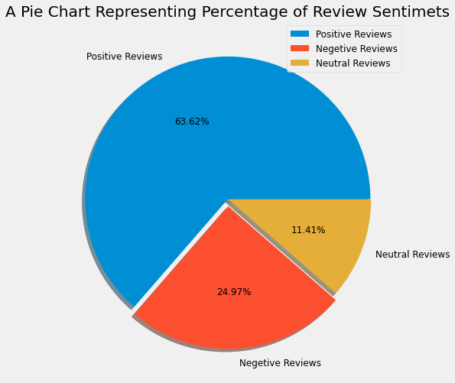

**CONCLUSION AND FUTURE WORK**

* Thus the app development companies could decide what application should be developed and they can also see the prediction of their developed application. In this they also get to see the categorized reviews of all the application in one interface which will help them decide which app is liked by the users and which apps need to be developed more.
* The dataset contains immense possibilities to improve business values and have a positive impact. It is not limited to the problem taken into consideration for this project.
* We could add a system that would create application on its own by using the data set and creating the best user interface by the highly rated apps.

.